# Sequence Diagrams

## Choose Scheme

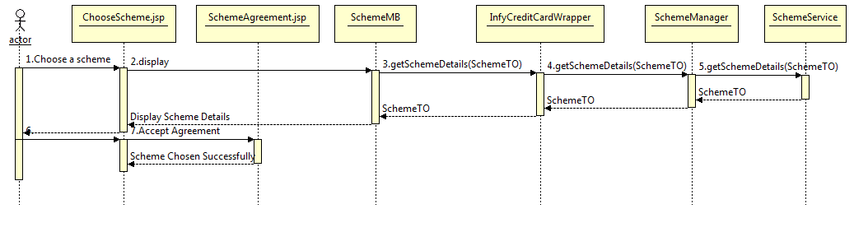

## Card Usage Details

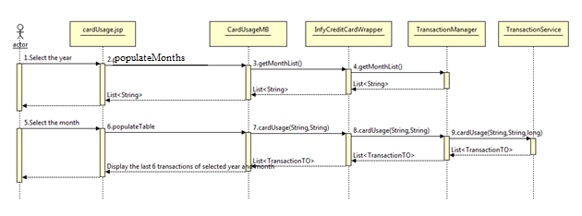

**DIAGRAM CLASSES:**

# Entities

### SchemeEntity

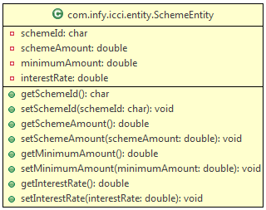

### Scheme Entity Bean Class

### Class Identification

|  |  |
| --- | --- |
| Class Name | SchemeEntity |
| **Class Description** | This class is mapped to the ICCI_SCHEME. |
| **Class Inheritance** | NA |
| **Classes Referenced** |  |
| **Sub System** | NA |
| **Class Type** | *Complete* |
| **Change History** | *NA* |

### Attributes (or Data members)

|  |  |  |  |  |
| --- | --- | --- | --- | --- |
| **Attribute Name** | **Description** | **Type** | **Scope** | **Range** |
| schemeId | Id used to identify various schemes | char | *private* |  |
| schemeAmount | Scheme amount | double | *private* |  |
| minimumAmount | Minimum amount to be paid for choosing a particular scheme | double | *private* |  |
| interestRate | Interest rate applicable if full scheme amount is not paid | double | *private* |  |

### Methods (or class functions)

The appropriate Getter and Setter methods for all the Data members mentioned.

# Managed Beans

### Card Usage

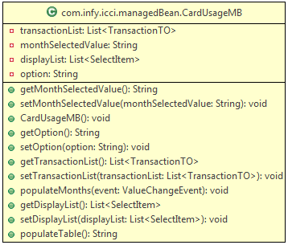

### Card Usage MB

### Class Identification

|  |  |
| --- | --- |
| Class Name | CardUsageMB |
| **Class Description** | This is used as the backing bean for the JSP. |
| **Class Inheritance** | NA |
| **Classes Referenced** |  |
| **Sub System** | NA |
| **Class Type** | *Complete* |
| **Change History** | *NA* |

### Attributes (or Data members)

|  |  |  |  |  |
| --- | --- | --- | --- | --- |
| **Attribute Name** | **Description** | **Type** | **Scope** | **Range** |
| transactionList | This is the list used to populate the data table | List<TransactionTO> | *private* |  |
| monthList | This is list of months used to populate the drop down. | List<SelectItem> | *private* |  |
| monthSelectedValue | This is the value chosen by theuser from the drop down. | String | *private* |  |
| Option | This is the valus chosen by the user from radio button, to indicate whther he wants month list for current year or previous year. | String | *private* |  |

|  |  |
| --- | --- |
| **Method** | **public String populateTable()** |
| Purpose and algorithm description | * This method is used as the action listener for the submit button. * This method creates a object of Wrapper and invokes the cardUsage() method of the wrapper by passing the **monthSelectedValue** and **option** chosen by the user. **Option** will either be ‘**current’ or ‘previous’.** * It returns ‘Success’ or ‘Failure’ depending on the return value of the method invoked. * On successful completion, the datatable in the front end is populated with the list of Transaction Objects returned from the cardUsage() method invocation. * Else, redirect to appropriate error page. |
| EntityBeans/ ValueObjects Used | InfyCreditaCardWrapper, TransactionTO |
| Exceptions |  |
| Special Notes | N.A |

|  |  |
| --- | --- |
| **Method** | **public void populateMonths(ValueChangeEvent event)** |
| Purpose and algorithm description | * This method is used as a value change event handler for the option button. * An object of TransactionManager is created and the **getMonthList()**  methos is invoked. * If the “**current”** option is chosen then, the first List is displayed. If the “**previous”** option is chosen then the Second List is retrieved from the getMonthList() method invocation and displayed. |
| EntityBeans/ ValueObjects Used | TransactionTO, TransactionManager |
| Exceptions |  |
| Special Notes | N.A |

### 2.2 SchemeMB

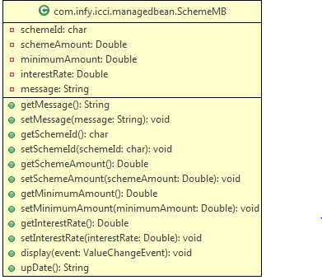

### SchemeMB

### Class Identification

|  |  |
| --- | --- |
| Class Name | SchemeMB |
| **Class Description** | This is used as the backing bean for the JSP. |
| **Class Inheritance** | NA |
| **Classes Referenced** |  |
| **Sub System** | NA |
| **Class Type** | *Complete* |
| **Change History** | *NA* |

### Attributes (or Data members)

|  |  |  |  |  |
| --- | --- | --- | --- | --- |
| **Attribute Name** | **Description** | **Type** | **Scope** | **Range** |
| cardNo | The 16-digit card number got by the four card numbers. | Long | *private* |  |
| cardNo1 | 4 digit card number | String | *Private* |  |
| cardNo2 | 4 digit card number | String | *Private* |  |
| cardNo3 | 4 digit card number | String | *Private* |  |
| cardNo4 | 4 digit card number | String | *Private* |  |
| Pin | Pin Number of the card | String | *Private* |  |
| dateOfRegistration | The date on which the customer registered | Date | *Private* |  |
| cardAmount | Amount available with the card | double | *Private* |  |
| balanceAmount | Amount to be paid by the customer | double | *Private* |  |
| Message | Displays the messages to the user | String | *private* |  |

|  |  |
| --- | --- |
| **Method** | **public String update()** |
| Purpose and algorithm description | Updates the scheme details for the customer if he does not have any scheme for his card. It first invokes the schemeChosen() method and if no scheme is chosen, updates the scheme details. |
| EntityBeans/ ValueObjects Used | InfyCreditCardWrapper, CardTO,CustomerTO |
| Exceptions |  |
| Special Notes | N.A |

|  |  |
| --- | --- |
| **Method** | **public void display(ValueChangeEvent event)** |
| Purpose and algorithm description | Displays the details of a corresponding scheme. |
| EntityBeans/ ValueObjects Used | InfyCreditCardWrapper,SchemeTO |
| Exceptions |  |
| Special Notes | N.A |

# Service Classes

### SchemeService

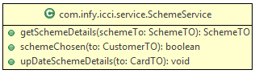

### SchemeService Class

### Class Identification

|  |  |
| --- | --- |
| Class Name | SchemeService |
| **Class Description** | This class is responsible for the data service tier methods related to available schemes. |
| **Class Inheritance** | NA |
| **Classes Referenced** | SchemeTO |
| **Sub System** | NA |
| **Class Type** | *Complete* |
| **Change History** | *NA* |

### Attributes (or Data members)

NA

### Methods (or class functions)

|  |  |
| --- | --- |
| **Method** | **Public SchemeTO getSchemeDetails(SchemeTO to)** |
| Purpose and algorithm description | Retrieve and return scheme details of the scheme whose schemeid is specified as part of SchemeTO |
| EntityBeans/ ValueObjects Used | SchemeTO |
| Exceptions | InvalidScheme |
| Special Notes | N.A |

### Attributes (or Data members)

NA

### 4.3.3.5Methods (or class functions)

|  |  |
| --- | --- |
| **Method** | **Public Boolean schemeChosen(CustomerTO customerTo)** |
| Purpose and algorithm description | Checks whether the customer has already chosen one scheme. |
| EntityBeans/ ValueObjects Used | Customer Entity, Card Entity |
| Exceptions | SQLException, Exception |
| Special Notes | N.A |

### Attributes (or Data members)

NA

### 4.3.3.7 Methods (or class functions)

|  |  |
| --- | --- |
| **Method** | **Public void updateSchemeDetails(CardTO cardTo)** |
| Purpose and algorithm description | Updates the card entity with the scheme details chosen by the customer. |
| EntityBeans/ ValueObjects Used | Card Entity |
| Exceptions | SQLException, Exception |
| Special Notes | N.A |

### 4.3.3.8Attributes (or Data members)

NA

### Methods (or class functions)

|  |  |
| --- | --- |
| **Method** | **Public Boolean schemeChosen(CustomerTO customerTo)** |
| Purpose and algorithm description | Checks whether the customer has already chosen one scheme. |
| EntityBeans/ ValueObjects Used | Customer Entity, Card Entity |
| Exceptions | SQLException, Exception |
| Special Notes | N.A |

### Methods (or class functions)

|  |  |
| --- | --- |
| **Method** | **Public void updateSchemeDetails(CardTO cardTo)** |
| Purpose and algorithm description | Updates the card entity with the scheme details chosen by the customer. |
| EntityBeans/ ValueObjects Used | Card Entity |
| Exceptions | SQLException, Exception |
| Special Notes | N.A |

|  |  |
| --- | --- |
| **Method** | **Public CardTO getCardDetailsForUpdate (CardTO cardTO)** |
| Purpose and algorithm description | * Get the card details for the particular customer |
| EntityBeans/ ValueObjects Used | CardEntity |
| Exceptions |  |
| Special Notes | N.A |

### TransactionService

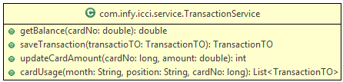

### Transaction Service Class

### Class Identification

|  |  |
| --- | --- |
| Class Name | TransactionService |
| **Class Description** | This class is responsible for the data service tier methods related to making a transaction |
| **Class Inheritance** | NA |
| **Classes Referenced** | TransactionTO |
| **Sub System** | NA |
| **Class Type** | *Complete* |
| **Change History** | *NA* |

### Attributes (or Data members)

NA

### Methods (or class functions)

|  |  |
| --- | --- |
| **Method** | **public double getBalance(long cardNo)** |
| Purpose and algorithm description | return the current available cardAmount for the corresponding card. |
| EntityBeans/ ValueObjects Used | transactionTO |
| Exceptions |  |
| Special Notes | N.A |

|  |  |
| --- | --- |
| **Method** | **public TransactionTO saveTransaction(TransactionTO transactionTO)** |
| Purpose and algorithm description | to persist the transaction details and to return the other transaction details like dateOfTransaction, auto generated transactionid, etc. |
| EntityBeans/ ValueObjects Used | transactionTO |
| Exceptions |  |
| Special Notes | N.A |

|  |  |
| --- | --- |
| **Method** | **public void updateCardAmount(double amount, long cardNo)** |
| Purpose and algorithm description | to update the cardAmount by the specified value for the corresponding card. |
| EntityBeans/ ValueObjects Used | transactionTO |
| Exceptions |  |
| Special Notes | N.A |

|  |  |
| --- | --- |
| **Method** | **public List<TransactionTO> cardUsage(String month, String year, long cardNo )** |
| Purpose and algorithm description | based on what month the user passes and the year (whether “current” or “previous”) return a list of TransactionTO, for the transactions **on that** **month and year chosen.** |
| EntityBeans/ ValueObjects Used | TransactionTO |
| Exceptions | NoProductsAvailableException |
| Special Notes | N.A |

# Manager Class

### SchemeManager

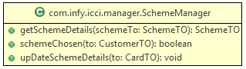

### SchemeManager Class

### Class Identification

|  |  |
| --- | --- |
| Class Name | SchemeManager |
| **Class Description** | This class is responsible for interaction with the service class |
| **Class Inheritance** | NA |
| **Classes Referenced** | SchemeTO, SchemeService |
| **Sub System** | NA |
| **Class Type** | *Complete* |
| **Change History** | *NA* |

### Attributes (or Data members)

NA

### Methods (or class functions)

|  |  |
| --- | --- |
| **Method** | **public SchemeTO getSchemeDetails(SchemeTO to)** |
| Purpose and algorithm description | * Invokes the appropriate service class method to get the details of the scheme whose schemeid is set in SchemeTO. |
| EntityBeans/ ValueObjects Used | SchemeTO, SchemeService |
| Exception | InvalidCardNo, InvalidScheme |
| Special Notes | N.A |

|  |  |
| --- | --- |
| **Method** | **Public SchemeTO getSchemeDetails(SchemeTO schemeTO)** |
| Purpose and algorithm description | * Gets the scheme details for a particular scheme by calling the service method |
| EntityBeans/ ValueObjects Used | SchemeTO,SchemeService |
| Exceptions |  |
| Special Notes | N.A |

|  |  |
| --- | --- |
| **Method** | **Public boolean schemeChosen(CustomerTO customerTO)** |
| Purpose and algorithm description | * Checks if the customer has already chosen a scheme. |
| EntityBeans/ ValueObjects Used | CustomerTO,SchemeService |
| Exceptions |  |
| Special Notes | N.A |

|  |  |
| --- | --- |
| **Method** | **Public void upDateSchemeDetails(CardTO cardTO)** |
| Purpose and algorithm description | * Updates the scheme details by calling the appropriate service method. |
| EntityBeans/ ValueObjects Used | CardTO, SchemeService |
| Exceptions |  |
| Special Notes | N.A |

|  |  |
| --- | --- |
| **Method** | **Public CardTO getCardDetailsForUpdate (CardTO cardTO)** |
| Purpose and algorithm description | * Get the card details for the customer by calling the service method. |
| EntityBeans/ ValueObjects Used | CardTO, SchemeService |
| Exceptions |  |
| Special Notes | N.A |

### TransactionManager

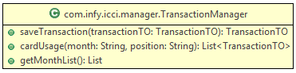

TransactionManager Class

### Class Identification

|  |  |
| --- | --- |
| Class Name | TransactionManager |
| **Class Description** | This class is responsible for the business service tier methods related to Transaction |
| **Class Inheritance** | NA |
| **Classes Referenced** | TransactionTO, TransactionService |
| **Sub System** | NA |
| **Class Type** | *Complete* |
| **Change History** | *NA* |

### Attributes (or Data members)

NA

### Methods (or class functions)

|  |  |
| --- | --- |
| **Method** | **Public TransactionTO saveTransaction(TransactionTO transactionTO)** |
| Purpose and algorithm description | * based on session handling retrieve the cardNo used for logging in. * pass the card no to getBalance() method of TransactionService * If the balance returned is less than the transaction Amount raise an exception. * If balance is greater than transaction amount, call the updatecardAmount() method of TransactionService * After that call the saveTransaction() method of TransactionService. |
| EntityBeans/ ValueObjects Used | TransactionTO, TransactionService |
| Exceptions | lowBalanceException |
| Special Notes | N.A |

|  |  |
| --- | --- |
| **Method** | **public List getMonthList()** |
| Purpose and algorithm description | * This method is used to generate a **list of list of months** to be used to populate the drop down in front end. * This List is used to populate the drop down in front end, which displays a list of last 6 months from the current date. * Please refer the diagram for further clarification. * The purpose is to make sure that only the last 6 months are displayed depending on the current date. * List 1 contains the months that fall in the current year and List 2 contains months that fall in the previous year. * Add both List 1 and List 2 to a List and return it. |
| EntityBeans/ ValueObjects Used | TransactionTO, TransactionService |
| Exceptions |  |
| Special Notes | N.A |

|  |  |
| --- | --- |
| **Method** | **public List<TransactionTO> cardUsage(String month, String year)** |
| Purpose and algorithm description | * This method uses the month and year selected by the user and returns a List of TransactionTO Objects. * Month is the ‘month’ chosen from drop down. * Year is the ‘year’ chosen from the radio button at front end. * In this method, the card No is obtained using session handling. Using sessions, obtain the card no which the user used to login. * Call the cardUsage() of TransactionService by passing the month, year and cardNo. |
| EntityBeans/ ValueObjects Used | TransactionTO, TransactionService |
| Exceptions |  |
| Special Notes | N.A |

# Wrapper Class

### InfyCreditCardWrapper

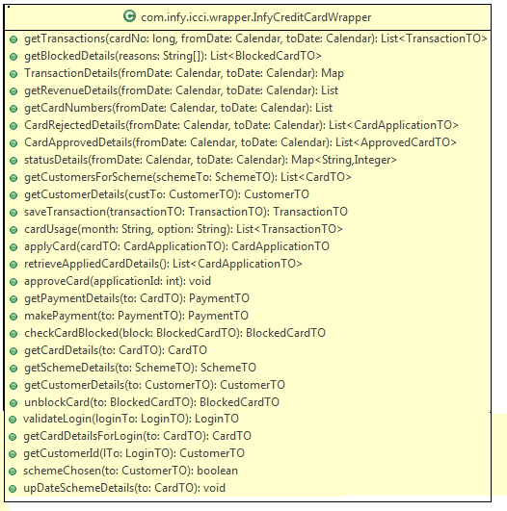

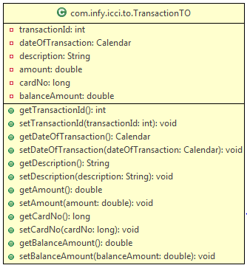

## Wrapper Class

### InfyCreditCardWrapper

### Class Identification

|  |  |
| --- | --- |
| Class Name | InfyCreditCardWrapper |
| **Class Description** | This class is responsible for acting as an interface between the Manager tier and the controller servlet in the presentation tier. |
| **Class Inheritance** | NA |
| **Classes Referenced** | All TO’s and All BS classes |
| **Sub System** | NA |
| **Class Type** | *Complete* |
| **Change History** | *NA* |

### Attributes (or Data members)

NA

### Methods (or class functions)

All the below mentioned methods should to call their respective methods in the respective Manager classes. The methods in both the Wrapper class and the Managers classes are the same. No logic is implemented in the method in this class.

|  |  |
| --- | --- |
| **Method** | **public TransactionTO saveTransaction(TransactionTO to)** |

|  |  |
| --- | --- |
| **Method** | **public List<TransactionTO> cardUsage(String month, String option)** |

|  |  |
| --- | --- |
| **Method** | **public CardApplicationTO applyCard(CardApplicationTO to)** |

|  |  |
| --- | --- |
| **Method** | **public List<CardApplicationTO> retrieveAppliedCardDetails()** |

|  |  |
| --- | --- |
| **Method** | **public void approveCard(int applicantId)** |

|  |  |
| --- | --- |
| **Method** | **public PaymentTO getPaymentDetails(CardTO to)** |

|  |  |
| --- | --- |
| **Method** | **public PaymentTO makePayment(PaymentTO to)** |

|  |  |
| --- | --- |
| **Method** | **public BlockedCardTO checkCardBlocked(BlockedCardTO to)** |

|  |  |
| --- | --- |
| **Method** | **public CardTO getCardDetails(CardTO to)** |

|  |  |
| --- | --- |
| **Method** | **public SchemeTO getSchemeDetails(SchemeTO to)** |

|  |  |
| --- | --- |
| **Method** | **public CustomerTO getCustomerDetails(CustomerTO to)** |

|  |  |
| --- | --- |
| **Method** | **public BlockedCardTO unblockCard(BlockedCardTO to)** |

|  |  |
| --- | --- |
| **Method** | **public LoginTO validateLogin(LoginTO to)** |

|  |  |
| --- | --- |
| **Method** | **public CardTO getCardDetailsForLogin(CardTO to)** |

|  |  |
| --- | --- |
| **Method** | **public CustomerTO getCustomerId(LoginTO to)** |

|  |  |
| --- | --- |
| **Method** | **public boolean schemeChosen(CustomerTO customerTo)** |

|  |  |
| --- | --- |
| **Method** | **public void upDateSchemeDetails(CardTO cardTo)** |

|  |  |
| --- | --- |
| **Method** | **public CardTO getSchemeDetails(CardTO cardTo)** |

|  |  |
| --- | --- |
| **Method** | **public Map TransactionDetails(Calendar fromDate, Calendar toDate)** |

|  |  |
| --- | --- |
| **Method** | **public List<TransactionTO> getTransactions(long cardNo, Calendar fromDate, Calendar toDate)** |

|  |  |
| --- | --- |
| **Method** | **public List<BlockedCardTO> getBlockedDetails(String[] reasons)** |

|  |  |
| --- | --- |
| **Method** | **public List getRevenueDetails(Calendar fromDate, Calendar toDate)** |

|  |  |
| --- | --- |
| **Method** | **Public List<CardTO> getCustomersForScheme(SchemeTO schemeTo)** |

|  |  |
| --- | --- |
| **Method** | **Public CustomerTO getCustomersDetails(CustomerTO customerTo)** |

|  |  |
| --- | --- |
| **Method** | **public List getCardNumbers(Calendar fromDate,Calendar toDate)** |
| **Method** | **public List<CardApplicationTO> CardRejectedDetails (Calendar fromDate,Calendar toDate)** |
| **Method** | **public List<ApprovedCardTO> CardApprovedDetails (Calendar fromDate,Calendar toDate)** |
| **Method** | **public Map<String,Integer> statusDetails (Calendar fromDate,Calendar toDate)** |

# Transfer Objects

### SchemeTO

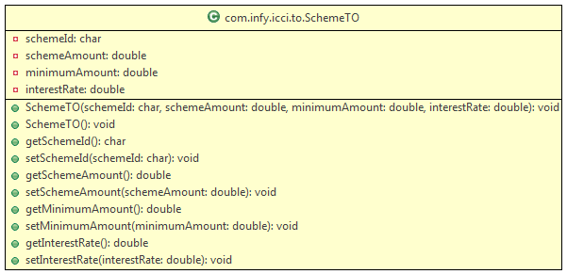

### SchemeTO Class

### Class Identification

|  |  |
| --- | --- |
| Class Name | SchemeTO |
| **Class Description** | The class is used to transfer scheme related details. |
| **Class Inheritance** | NA |
| **Classes Referenced** |  |
| **Sub System** | NA |
| **Class Type** | *Complete* |
| **Change History** | *NA* |

### Attributes (or Data members)

|  |  |  |  |  |
| --- | --- | --- | --- | --- |
| **Attribute Name** | **Description** | **Type** | **Scope** | **Range** |
| schemeId | Id used to identify various schemes | char | *private* |  |
| schemeAmount | Scheme amount | double | *private* |  |
| minimumAmount | Minimum amount to be paid for choosing a particular scheme | double | *private* |  |
| interestRate | Interest rate applicable if full scheme amount is not paid | double | *private* |  |

### Methods (or class functions)

The appropriate Getter and Setter methods for all the Data members mentioned.

### TransactionTO



### TransactionTO

### Class Identification

|  |  |
| --- | --- |
| Class Name | TransactionTO |
| **Class Description** | This class is used to transfer transaction related data between tiers. |
| **Class Inheritance** | NA |
| **Classes Referenced** | NA |
| **Sub System** | NA |
| **Class Type** | *Complete* |
| **Change History** | *NA* |

### Attributes (or Data members)

|  |  |  |  |  |  |  |  |
| --- | --- | --- | --- | --- | --- | --- | --- |
| **Attribute Name** | **Description** | **Type** | | **Scope** | | **Range** | |
| transactionId | uniqueId which identifies the transaction on a card | | int | | *private* | |  |
| dateOfTransaction | This is the date on which a particular transaction was made on the card | | Calendar | | *private* | |  |
| description | this is the description on what was purchased in the transaction | | String | | *private* | |  |
| amount | This is the transaction amount | | double | | *private* | | amount |
| cardNo | This is the CardNO on which a transaction was made. | | long | | *private* | | cardNo |
| balanceAmount | This is the balance amount | | double | | *private* | |  |

### Methods (or class functions)

The appropriate Getter and Setter methods for all the Data members mentioned.